**A PROJECT REPORT**

ON

**AN IOT BASED PROFICIENT SYSTEM FOR OBJECT AND CRACK DETECTION IN A RAILWAY SYSTEM**

*Submitted in the partial fulfillment for the award of the degree*

**BACHELOR OF TECHNOLOGY**

*In*

**COMPUTER SCIENCE & ENGINEERING**

**SUBMITTED BY:**

**CH. HARSHITH (17B81A05R2)**

**N. SUSHEEL MARUTHI REDDY (17B81A05S4)**

**G. VINAY (17B81A05V0)**

*Under the Supervision of*

**Ms. P. MADHAVI**

*Assistant professor, CSE Dept.*

***CVR college of Engineering***



DEPARTMENT OF COMPUTER SCIENCE & ENGINEERING

CVR COLLEGE OF ENGINEERING

(An Autonomous institution, NBA, NAAC Accredited & Affiliated to JNTU-H, Hyderabad)

Vastunagar, Mangalpalli (V), Ibrahimpatnam (M), Rangareddy (D), Telangana- 501 510

Web: <http://cvr.ac.in>, Email: [info@cvr.ac.in](mailto:info@cvr.ac.in)

** Cherabuddi Education Society’s**

**CVR COLLEGE OF ENGINEERING**

**(An Autonomous Institution)**

**ACCREDITED BY NBA, NAAC ‘A’ GRADE**

(Approved by AICTE & Government of Telangana and Affiliated to JNTU Hyderabad)

Vastunagar, Mangalpalli (V), Ibrahimpatnam (M), R.R. District, PIN-501 510

Web: <http://www.cvr.ac.in>, Email: [info@cvr.ac.in](mailto:info@cvr.ac.in)

Ph: 08414 – 252222, 252369, Office telefax: 252396, Principal: 252396 (O)

**Department of Computer Science and Engineering**

**CERTIFICATE**

This is to certify that the project entitled “**AN IOT BASED PROFICIENT SYSTEM FOR OBJECT AND CRACK DETECTION IN A RAILWAY SYSTEM**” that is being submitted by CH. HARSHITH (17B81A05R2), N. SUSHEEL MARUTHI REDDY (17B81A05S4), G. VINAY (17BA81A05V0) in partial fulfillment for the award of Bachelor of Technology in Computer Science and Engineering to the CVR College of Engineering, is a record of Bonafede work carried out by them under my guidance and supervision during the year 2020-2021.

The results embodied in this project work has not been submitted to any other University or Institute for the award of any degree or diploma.

**Project Guide Head of the Department**

**P. Madhavi Dr. A Vani Vathsala**

*Professor, CSE Dept Professor & HOD, CSE Dept.*

*CVR College of Engineering CVR College of Engineering*

**External Examiner**

**ACKNOWLEDGEMENT**

This satisfaction that accomplishes the successful completion of any tasks would be incomplete without the mention of the people who made it possible and whose encouragement and guidance has been a source of inspiration throughout the course of the project.

I Sincerely thank **Dr. Nayanathara K Sattiraju,** principal, CVR College of Engineering, for her cooperation and encouragement throughout the project.

We would also like to express our gratitude towards **Dr. A. Vani Vathsala,** Head of Computer Science Engineering Department and our professor in charge **Dr Selvakumar R.k.** who anchored our activities and supported us till the end of the project.

This Project has provided us a chance to apply our technical knowledge in real life applications. We are pleased to acknowledge **Mrs. P. Madhavi,** Assistant Professor for her invaluable guidance and contribution during the course of this project work.

**Yours Sincerely,**

Ch. Harshith -17B81A05R2

N. Susheel Maruthi Reddy -17B81A05S8

G. Vinay-17B81A05V0

**ABSTRACT**

The growth and usage of Wireless Sensor Networks have paved the way for the development of numerous applications. The development of this technology has produced a variety of instruments and models that are used to support their lifestyle. Numerous applications can be built by making use of smart objects to make an effective environment. Railways are one of the biggest backbones in India. A lot of manpower is required to maintain such a huge population and also to provide efficient transportation. In this paper, we have introduced a model that is capable of reducing the overall workload of the railway system by monitoring it. The system makes use of various sensors such as Ultrasonic sensors, IR sensor and MEMS sensors. Raspberry Pi microcontroller is used as a platform to build the entire model that is able to detect cracks and objects effectively in railway tracks. Other technologies such as GSM and GPS services are effectively used to detect the location of the obstacle and convey the alert to the respective authority. The performance of the model is evaluated and is observed to be much more efficient compared to the traditional monitoring system.

Keywords: Railway monitoring System. GSM, GPS, Raspberry Pi, WSNs

|  |  |  |  |  |
| --- | --- | --- | --- | --- |
| **Table of Contents** | | | | |
|  | | | | Page No. |
| 1 | | | **Introduction** | 1-3 |
|  | 1.1 | | Motivation | 1-2 |
|  | 1.2 | | Problem Statement | 3 |
|  | 1.3 | | Project Objectives | 3 |
|  | 1.4 | | Project Report Organization | 3 |
| 2 | | | **Literature Survey** | 4 |
|  | 2.1 | | Existing Work | 4 |
|  | 2.2 | | Limitations of Existing Work | 4 |
| 3 | | | **Software & Hardware Specifications** | 5-10 |
|  | 3.1 | | Purpose | 5 |
|  | 3.2 | | Project Scope and Feasibility Study | 5 |
|  | 3.3 | | Intended Audience | 5 |
|  | 3.4 | | Functional Requirements | 6 |
|  | 3.5 | | Non-Functional Requirements | 6 |
|  | 3.6 | | Software Requirements | 7-8 |
|  |  | 3.6.1 | Python | 7 |
|  |  | 3.6.2 | Linux | 7 |
|  |  | 3.6.3 | NumPy | 7 |
|  |  | 3.6.4 | GPIO | 7 |
|  |  | 3.6.5 | MIME | 7 |
|  |  | 3.6.6 | Pyserial | 8 |
|  |  | 3.6.7 | ARM Linux | 8 |
|  | 3.7 | | Hardware Requirements | 9-10 |
|  |  | 3.7.1 | Raspberry Pi | 9 |
|  |  | 3.7.2 | IR Sensor | 9 |
|  |  | 3.7.3 | Ultrasonic Sensor | 9 |
|  |  | 3.7.4 | GSM Modem | 9 |
|  |  | 3.7.5 | Raspberry pi GPS module | 9 |
|  |  | 3.7.6 | DC Motor | 10 |
|  |  | 3.7.7 | IOT power relay | 10 |
|  |  | 3.7.8 | Relay H bridge | 10 |
| 4 | | | **Design** | 11-19 |
|  | 4.1 | | Frequency range of sound | 11-12 |
|  | 4.2 | | IR sensor | 13 |
|  | 4.3 | | DC Motor | 14 |
|  | 4.4 | | GPS communication | 15 |
|  | 4.5 | | Raspberry pi device | 16 |
|  | 4.6 | | Block diagram for proposed model | 17 |
|  | 4.7 | | Block diagram for proposed approach | 18-19 |
| 5 | | | **Implementation and Testing** | 20-28 |
|  | 5.1 | | Sensor Implementation | 20-24 |
|  |  | 5.1.1 | Ultrasonic sensor functionality | 20 |
|  |  | 5.1.2 | IR sensor functionality | 22 |
|  |  | 5.1.3 | OPENCV functionality | 23 |
|  | 5.2 | | Test Cases | 25-27 |
|  |  | 5.2.1 | Performance Evaluation of Proposed Model | 25 |
|  |  | 5.2.2 | Efficiency of Proposed Model | 26 |
|  |  | 5.2.3 | Testing the proximity of proposed model | 27 |
|  | 5.3 | | Final Model Manifestation | 28 |
| 6 | | | **Conclusion and Future Enhancements** | 29 |
|  |  |  | **Abbreviations** | 30 |
|  |  |  | **References** | 31 |

|  |  |  |
| --- | --- | --- |
| **List of Tables** | | |
|  | | Page No. |
| 1.1.1 | NUMBER OF RAIL ACCIDENTS CAUSED IN INDIAN RAILWAYS DUE TO DIFFERENT REASONS DURING THE YEAR 2003-04 & 2009-10 | 2 |
| 1.1.2 | NUMBER OF RAIL ACCIDENTS CAUSED IN INDIAN RAILWAYS DUE TO DIFFERENT REASONS DURING THE YEAR 2010-11 TO 2015-16 | 2 |

**LIST OF FIGURES**

|  |  |  |
| --- | --- | --- |
| **Figure No.** | **Title** | **Page No** |
| **Fig 4.1** | Frequency range of sound | 11 |
| **Fig 4.2** | IR circuit | 12 |
| **Fig 4.3** | DC motor | 13 |
| **Fig 4.4** | GPS communication | 14 |
| **Fig 4.5** | Raspberry Pi device | 15 |
| **Fig 4.6** | Block diagram for proposed model | 16 |
| **Fig 4.7** | Block diagram for proposed approach | 17 |
| **Fig 5.2.1** | Performance Evaluation | 25 |
| **Fig 5.2.2** | Efficiency for model | 26 |
| **Fig 5.3** | Final model manifestation | 28 |

**1.INTRODUCTION**

**1.1 MOTIVATION**

India has emerged as a very progressive country in various fields of technology development in the last few decades and the transportation network is never an exception. Wide variety of applications and systems are being researched upon and also been proposed for making it more efficient and secure [1]. India's population also plays a vital role in the transportation system. Though many new approaches and security systems are built for our country it is always very less because of our increasing population. Wireless Sensor Networks play a vital role in connecting numerous sensors and managing the information being stored and processed in it. There are numerous applications where WSNs play a vital role in making necessary emergencies in numerous applications. Development in the satellite systems and the use of the internet has played a key role in numerous system models. Satellite tracking of vehicles such as GPS services globally called a Global Positioning System has played a vital role in tracking the vehicles [2]. Numerous applications such as food delivery services [5], tracking the exact location of trains [4], booking of cabs [3], and Google Maps [6] immensely depend on the Global Positioning System. Vehicle tracking systems are being widely used by almost all people in day-to-day life. Today GPS used in cars, flights, ambulances, and police vehicles are common sights on the roads of developed countries [7]. Railways are one of the most important and vital backbones of our country. Numerous passengers tend to travel and use this as the main medium of transport from one place to another [5]. There are numerous accidents that tend to occur, and the rate of accidents is growing higher as the population. Table I gives the exact number of various occurrences of accidents in our Indian Railways from the year 2010-11 to 2015-16. The Internet of things (IoT) describes the network of physical objects, "things" that are embedded with sensors, software, and other technologies for the purpose of connecting and exchanging data with other devices and systems over the Internet. So, with the help of IOT technology and WSN, we are motivated to develop a model device which senses the obstacle and detects cracks. **Wireless sensor network** (**WSN**) refers to spatially dispersed and dedicated sensors that monitor and record the physical conditions of the environment and forward the collected data to a central location.

Wireless Sensor Networks play a vital role in connecting numerous sensors and managing the information being stored and processed in it. There are numerous applications where WSNs play a vital role in making necessary emergencies in numerous applications. Development in the satellite systems and the use of WSN helps in IOT.

The internet has played a key role in numerous system models. Satellite tracking of vehicles such as GPS services globally called a Global Positioning System has played a vital role in tracking the vehicles. The rover essentially solves many issues by evolving as a suitable device to track and identify.

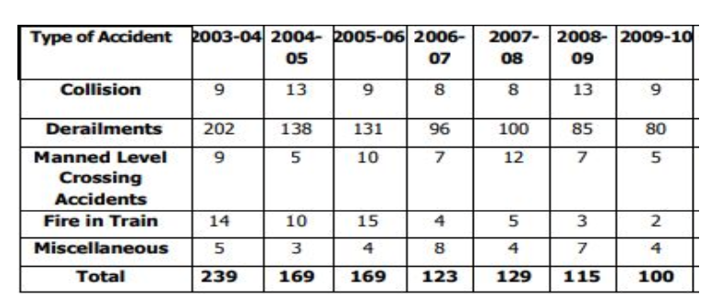

TABLE 1.1.1: THE RECORDS OF RAIL ACCIDENTS DURING 2003-10

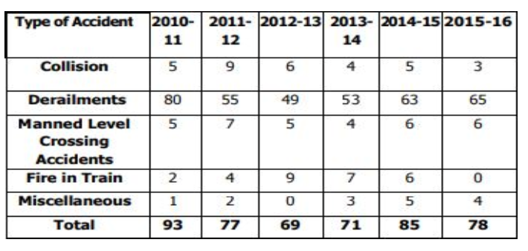

TABLE 1.1.2: THE RECORDS OF RAIL ACCIDENTS DURING 2010-16

**1.2 PROBLEM STATEMENT**

It is an independent device for detection/sensing the obstacles and cracks on railway lines. Major obstacles might be moving or static obstacles, in order to sense them and provide the information back to concerned authorities is the purpose of this device. The requirements based on the device includes IOT technology with the help of python which drives the functionality to achieve the goal to develop and provide an efficient working model.

* Real-Time detection and sensory work of obstacles and cracks within the proximity of the sensors in the proposed model.
* Two types of obstacles are selected for this model to achieve its targets. Static and moving obstacles.
* Various sensors like IR sensor, ultrasonic sensors are used to achieve the goal.
* The efficiency and performance should be always positive to make the device running.

**1.3 PROBLEM OBJECTIVES**

In order to reduce the risk of losing several lives in train accidents, in this project we have proposed a model for detecting obstacles and cracks in railway tracks using various sensors. The use of GSM and GPS is also done for identifying the location of the cracks and objects and communicating them to the concerned person. Various parameters are used for evaluating the performance of the model and are observed to be much more efficient when compared to other traditional monitoring systems. The main objective is to design a proper device model which can represent the problem accurately. The functionality can be developed by various modules, libraries and algorithms. This device model should essentially solve issues and it can be done by following a sequence of steps aligned to the model.

1. It Involves collection of data and helps to reach out for receiver.

2. The rover mainly helps to automate the process.

3. Automation leads to increase in speed, efficiency and reduced manpower.

**1.4 PROJECT REPORT ORGANIZATION**

In this report we will discuss about the literature survey, software & hardware specifications, implementation, testing, conclusion and future scope of the project in different chapters.

**2.LITERATURE SURVEY**

**2.1 EXISTING WORK**

There is no existing model or device such as the current development device. The existing system is completely manual. The manpower is used to inspect the track for obstacles as well as the cracks, various methods are used to inspect the track and the communication is not efficient to the concerned authority. It is more time complex as it is not efficient to find the obstacle/crack for a long range of lines. It is important to provide accurate and efficient information to act against the issue in an organized manner. It is necessary to solve the issue within the time or think about options to resolve the issue. But in the existing system there isn’t an efficient system to solve the problem. So, in order to solve the real time problem in railway track inspection and detection of cracks and also to sense the moving objects and take necessary actions to prevent loss of life. The project model helps to overcome all these issues and stand out as an efficient solution.

**2.2 LIMITATIONS OF EXISTING WORK**

1. It is not efficient to give the accurate location of the obstacle.
2. It is not accurate to sense the type of obstacles on the railway lines.
3. It is not accurate in detecting the type of cracks which may be horizontal or vertical.
4. The current inspection model is not so suitable, sometimes there may be negligence in inspecting the tracks.
5. The current model cannot inspect long ranges of tracks.
6. The current inspection work delays the process of signaling to the railways as it takes time to sense the type of issue on the track.
7. The delay in signaling is finding the solution and acting accordingly.
8. The complexity of the current model is very high.

**3.SOFTWARE REQUIREMENT SPECIFICATION**

**3.1 PURPOSE**

To minimize the time and effort required to inspect and give the issue information to the concerned authorities and to detect cracks and identify obstacles on the track. To increase efficiency, speed and reduce manpower. We state the requirements of the project in great detail. The successful achievement of these requirements will showcase that the undertaking of this project resulted in productive output.

**3.2 PROJECT SCOPE & FEASIBILITY STUDY**

The scope of the project is to develop and use to solve an essential problem. This solves the issue of train accidents and many more incidents on railway tracks. The effective way of functioning is to find the coordinates within proximity of the device and signal it back to concerned authorities.

Feasibility study is an assessment of the practicality of a proposed project. We are going to judge the feasibility of this project on the following factors: Technical Feasibility, Operational Feasibility.

The technical Feasibility assessment is focused on gaining an understanding of the present technical resources of the project and their applicability to the expected needs of the proposed system. It is an evaluation of the hardware and software requirements and how it meets the needs of the proposed system. The software needed are python 3.7 including GPIO,

MIME and SMTP lib and various libraries, protocols. The hardware requirements include various devices & sensors which are well within the team’s feasibility.

The Operational Feasibility is the measure of how well a proposed system solves the problems and takes the advantage of the opportunities identified during scope definition and how it satisfies the requirements identified in the requirements analysis phase of project development.

**3.3 INTENDED AUDIENCE**

This project is intended for railways as well as various tracking and detecting services within the requirement of an individual. Mostly, it is based on detecting and identifying the obstacles it can be used by various government and private organizations.

**3.4 FUNCTIONAL REQUIREMENTS**

Functional requirements are those which deal with the device provided for users. It describes the behavior of the system as it relates to the device functionality. It includes the description of the required functions and details of data to the user.

1. The device should detect cracks both vertically and horizontally on the track.
2. The device should identify the stable objects as well as moving objects.
3. The device should give the complete details of data to the user concisely.

**3.5 NON-FUNCTIONAL REQUIREMENTS**

Non-functional requirements are those requirements which elaborate the performance characteristics of the system and define the constraints on how the system will do so. It also Describes the standard function that should be provided. The major non-functional requirements this project incorporates are

1. Accessibility - The project needs to be easily accessible to the users.
2. Integrability - The project should have a high degree of integrability between the various sensors in the system and algorithm.
3. Usability - The project should have a high degree of usability to the defined core user group.
4. Reliability - The project should detect and identify the objects as expected.
5. Maintainability - The project should be maintainable so as to reduce errors and extend the development if needed.

**3.6 SOFTWARE REQUIREMENTS**

**3.6.1 Python**

Python is an interpreted, high-level, general purpose programming language. Created by Guido van Rossum and first released in 1991, Python has a design philosophy that emphasizes code readability, notably using significant whitespace. It provides constructs that enable clear programming on both small and large scales. Python first compiles source code (.py file) into byte code format (.pyc). The compilation is simply a translation step, and byte code is a lower level and platform independent representation of your source code. Compiled code is stored in .pyc and is regenerated when the source is updated, or when otherwise necessary. In order to distribute a program to people who already have python installed you can transfer either the .py files or the .pyc files.

**3.6.2 Linux**

Python is the language of choice for shell scripting and task automation. It is popular in system administration because it can execute shell commands using only its default libraries. In this tutorial, you will learn how to run Linux shell commands with Python using the os and subprocess modules.

**3.6.3 NumPy**

NumPy is a library for the python programming language, adding support for large, multidimensional arrays and matrices, along with a large collection of high-level multidimensional functions to operate on these arrays.

**3.6.4 GPIO**

GPIO stands for General Purpose Input/Output. It's a standard interface used to connect microcontrollers to other electronic devices. For example, it can be used with sensors, diodes, displays, and System-on-Chip modules.

**3.6.5 MIME**

Multipurpose Internet Mail Extensions (**MIME**) is an Internet standard that extends the format of email to support: - Text in character sets other than ASCII - Non-text attachments: audio, video, images, application programs etc.

**3.6.6 Pyserial**

Pyserial is a library which provides support for serial connections ("RS-232") over a variety of different devices: old-style serial ports, Bluetooth dongles, infra-red ports, and so on. It also supports remote serial ports via RFC 2217 (since V2. 5). This is the most essential library for IOT based projects which helps microcontrollers to support serial connections.

**Features of Pyserial:**

* Same class-based interface on all supported platforms.
* Access to the port settings through Python properties.
* Support for different byte sizes, stop bits, parity and flow control with RTS/CTS and/or Xon/Xoff.
* Working with or without receiving a timeout.
* File like API with “read” and “write” (“readline” etc. also supported).
* The files in this package are 100% pure Python.
* The port is set up for binary transmission. No NULL byte stripping, CR-LF translation etc. (which are many times enabled for POSIX.) This makes this module universally useful.
* Compatible with io library
* RFC2217 client (experimental).

**3.6.7 ARM Linux**

**Arm** Compiler toolchain takes full advantage of the most advanced **Arm** architecture features to generate fast, compact, and energy-efficient code for embedded applications. **Arm** Mbed OS is a free, open-source embedded operating system that is designed specifically for the Internet of Things. The Linux kernel provides scheduling, process and memory management, and a core set of features. When building an IoT device, Linux makes it easy to take advantage of peripherals (network or wireless interfaces, display interfaces, etc.) and to use them within their desired context.

**3.7 HARDWARE REQUIREMENTS**

**3.7.1 Raspberry Pi Microcontroller**

The Raspberry Pi is a low cost, credit-card sized computer that plugs into a computer monitor or TV and uses a standard keyboard and mouse. It is a capable little device that enables people of all ages to explore computing, and to learn how to program in languages like Scratch and Python. It’s capable of doing everything you’d expect a desktop computer to do, from browsing the internet and playing high-definition video, to making spreadsheets, word-processing, and playing games**.**

**3.7.2 IR Sensor**

An infrared sensor is an electronic device that emits in order to sense some aspects of the surroundings. An IR sensor can measure the heat of an object as well as detect the motion. These types of sensors measure only infrared radiation, rather than emitting it that is called a passive IR sensor.

**3.7.3 Ultrasonic Sensor**

An ultrasonic sensor is an electronic device that measures the distance of a target object by emitting ultrasonic sound waves and converts the reflected sound into an electrical signal. Ultrasonic waves travel faster than the speed of audible sound.

**3.7.4 GSM modem**

A GSM modem or GSM module is a hardware device that uses GSM mobile telephone technology to provide a data link to a remote network. ... GSM modems typically provide TTL-level serial interfaces to their host. They are usually used as part of an embedded system.

**3.7.5 Raspberry pi GPS module**

The GPS module has four connection pins, namely: Vcc, GND, TX and RX. It requires a power input 5V 100mA, which can be provided using any suitable supply source. The RX pin of Pi, i.e., the 10th GPIO pin on the RPi board, should be connected to the TX pin of the GPS module

**3.7.6 DC motor**

An electric motor is an electrical machine that converts electrical energy into mechanical energy. Most electric motors operate through the interaction between the motor's magnetic field and electric current in a wire winding to generate force in the form of torque applied on the motor's shaft**.**

**3.7.7 IOT Power relay**

The IoT Power Relay is designed to allow you to *safely* control an outlet device that operates at 3--48VDC or 12--120VAC. Each IoT Power Relay features a single input (from the included C13 power cable) to four outputs: one normally on, one always on, and two normally off. The durable SPDT control relay is rated at 30/40A, for 400,000 operations. With the IoT Power Relay you can easily control the power going to a device with an Arduino, Raspberry Pi or other single-board computer or microcontroller.

**3.7.8 Relay H bridge**

An H-bridge is an [electronic circuit](https://en.wikipedia.org/wiki/Electronic_circuit) that switches the polarity of a voltage applied to a load. These circuits are often used in [robotics](https://en.wikipedia.org/wiki/Robotics) and other applications to allow DC motors to run forwards or backwards.Most DC-to-AC converters ([power inverters](https://en.wikipedia.org/wiki/Power_inverter)), most [AC/AC converters](https://en.wikipedia.org/wiki/AC/AC_converter), the DC-to-DC [push–pull converter](https://en.wikipedia.org/wiki/Push%E2%80%93pull_converter), isolated [DC-to-DC converter, most](https://en.wikipedia.org/wiki/DC-to-DC_converter) [motor controllers](https://en.wikipedia.org/wiki/Motor_controller), and many other kinds of [power electronics](https://en.wikipedia.org/wiki/Power_electronics) use H bridges. In particular, a [bipolar stepper motor](https://en.wikipedia.org/wiki/Stepper_motor#Bipolar_motor) is almost always driven by a motor controller containing two H bridges. A common use of the H-bridge is an [inverter](https://en.wikipedia.org/wiki/Inverter_(electrical)). The arrangement is sometimes known as a single-phase bridge inverter. The H-bridge with a DC supply will generate a square wave voltage waveform across the load. For a purely inductive load, the current waveform would be a triangle wave, with its peak depending on the inductance, switching frequency, and input voltage.

**4.DESIGN**

This project works by usage of more hardware components and the device is built only with hardware components. The components are mentioned in hardware requirements (2.7).

The design involves various types of sensors and a microcontroller.

**4.1 FREQUENCY RANGE OF SOUND:**

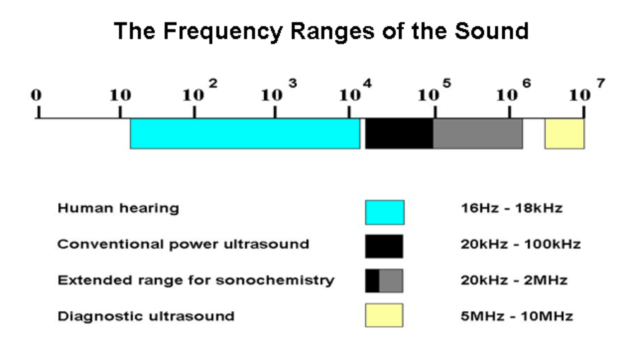

Fig 4.1: frequency ranges of sound

There are a variety of sensors based on other physical transduction principles like the optical range finding sensors and the microwave- based devices too. Then why should one use ultrasonic transducers in the first place, given that the speed of sound is much slower than the speed of electromagnetic waves? The answer lies in the question itself. Because the EM waves-based devices are too fast. Being slower than the EM waves, the time taken by ultrasonic waves is much longer than that taken by the latter and hence its measurement can be done more easily and less expensively. Because these are based on sound waves rather than EM waves, these would work in places where the latter would not.

For example, in the case of clear object detection and measurement of liquid levels or high glare environments, light-based sensors would suffer greatly because of the transmittance of the target or the translucence of the propagating media. Ultrasonic devices being based upon sound propagation would remain practically unaffected. These also function well in wet environments where optical beams may suffer from refraction from the water droplets in the environment. On account of range and accuracy, the ultrasonic sensors may lie in between two EM wave-based sensors, the Infrared rangefinders on the lower end and the LIDARs on the upper end. Not as accurate or long distance as the LIDARs, the Ultrasonic rangefinders fare better than the IR rangefinders which are highly susceptible to ambient conditions and require recalibration when environment changes. Further these devices offer advantage in medical imaging as compared to MRI or X-Ray scans due to inexpensiveness and portability. No harmful effects of ultrasonic waves at the intensity levels used have been detected in contrast to X- rays or radioactivity-based methods and are particularly suited for imaging soft tissues. There are a variety of sensors based on other physical transduction principles like the optical range finding sensors and the microwave-based devices too. Then why should one use ultrasonic transducers in the first place, given that the speed of sound is much slower than the speed of electromagnetic waves? The answer lies in the question itself. Because the EM waves-based devices are too fast. Being slower than the EM waves, the time taken by ultrasonic waves is much longer than that taken by the latter and hence its measurement can be done more easily and less expensively.

**4.2 IR Circuit :**

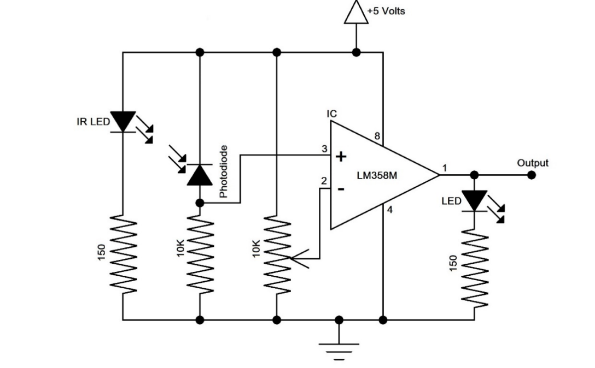

FIG 4.2: IR SENSOR CIRCUIT

The role of the IR sensor in the device is to sense some aspects of the surroundings. An IR sensor can measure the heat of an object as well as detect the motion. These types of sensors measure only infrared radiation, rather than emitting it that is called a passive IR sensor. The Passive Infrared (PIR) sensor is used to detect the presence of humans. But this detects the human only if they are in motion. ... Every human radiates the infrared energy of a specific wavelength range. The absorbed incident radiation changes the temperature of a material. These sensors work by focusing the infrared energy emitted by an object onto one or more photodetectors. These photodetectors convert that energy into an electrical signal, which is proportional to the infrared energy emitted by the object.

**4.3 DC MOTOR :**

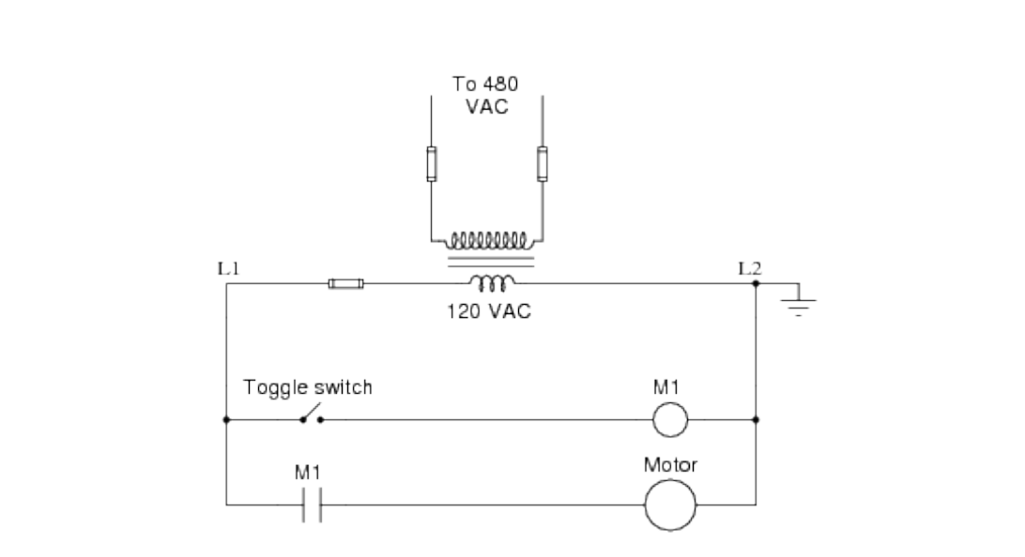

FIG 4.3: MOTOR CIRCUIT

A DC motor is used to drive a mechanical load. In this lab, a separately excited DC generator provides the load. The load on the motor is adjusted by varying the generator field current. By increasing the field current of the DC generator, the load on the DC motor increases and thus the armature current increases. In general, DC motors are characterized by their torque-speed curves as shown in Figure 9.1. Since the measuring equipment for shaft torque is not available in the lab it is necessary to use alternative means of characterizing the DC motor. One alternative is to plot shaft speed versus armature current since torque is directly proportional to the armature current

(T= *Ka*φ*d Ia*) with a constant field current supplied to the motor. Shaft speed is also a function of the field current in a DC motor while maintaining a constant armature voltage (*E a* = *K a* φ *d* ω) as field current is directly proportional to the direct axis flux produced in the machine.

**4.4 GPS COMMUNICATION:**

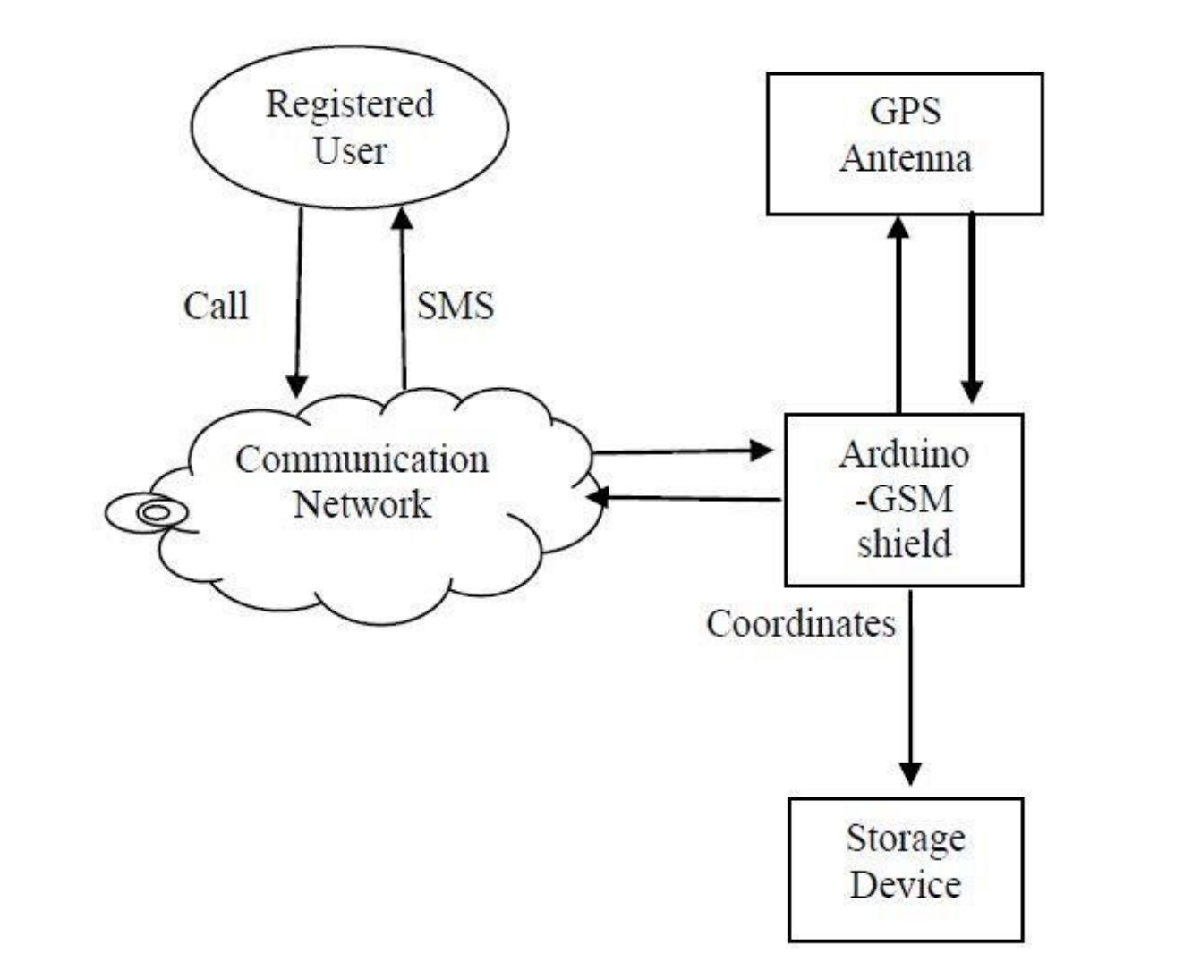

FIG 3.3: BASIC GPS COMMUNICATION

The GPS communication works as per the coordinates given to the input, when an obstacle/crack is detected or identified by various sensors the coordinates of object crack is sent to the registered user. The registered user will be receiving the input through any means of communication and react accordingly. For various means of communication there are various protocols used such as TCP, HTTP, SMTP are used.

The GSM Shield V2 connects the microcontroller to the internet using the WSN wireless network. Just plug this module onto the microcontroller, plug in a SIM card from an operator offering GPRS coverage and follow a few simple instructions to start controlling your world through the internet. You can also make/receive voice calls using the on-board audio/mic jack and send/receive SMS messages.

**4.5 RASPBERRY PI DEVICE:**

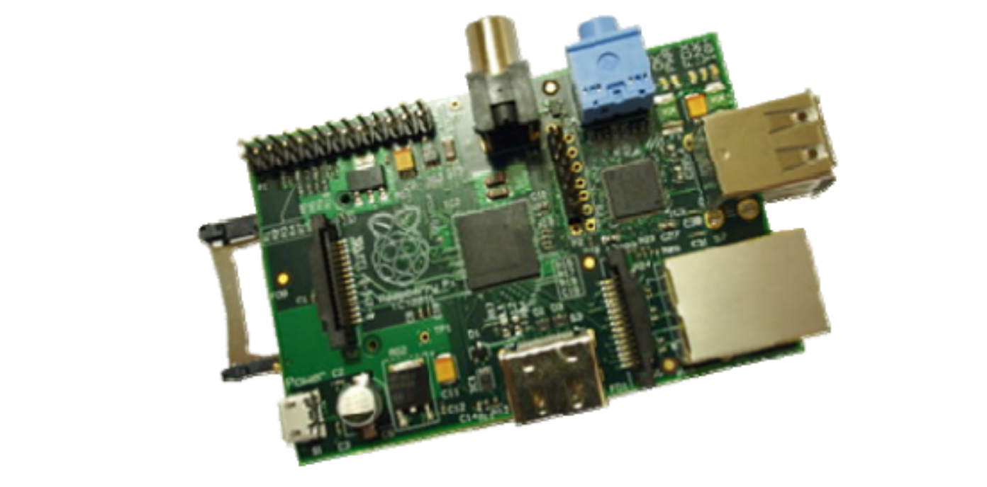

FIG 4.5: Micro controller

The Raspberry Pi board contains a processor and graphics chip, program memory (RAM) and various interfaces and connectors for external devices. Some of these devices are essential, others are optional. RPi operates in the same way as a standard PC, requiring a keyboard for command entry, a display unit and a power supply. It also requires ‘mass-storage’, but a hard disk drive of the type found in a typical PC is not really in keeping with the miniature size of RPi. Instead, we will use an SD Flash memory card normally used in digital cameras, configured in such a way to ‘look like’ a hard drive to RPi’s processor. RPi will ‘boot’ (load the Operating System into RAM) from this card in the same way as a PC ‘boots up’ into Windows from its hard disk.

The following are essential to get started:

• SD card containing Linux Operating system

• USB keyboard

• TV or monitor (with HDMI, DVI, Composite or SCART input)

• Power supply (see Section 1.6 below)

• Video cable to suit the TV or monitor used recommended optional extras include:

• USB mouse

• Internet connection, Model A or B: USB Wi-Fi adaptor

• Internet connection, Model B only: LAN (Ethernet) cable

**4.6 BLOCK DIAGRAM FOR PROPOSED MODEL:**

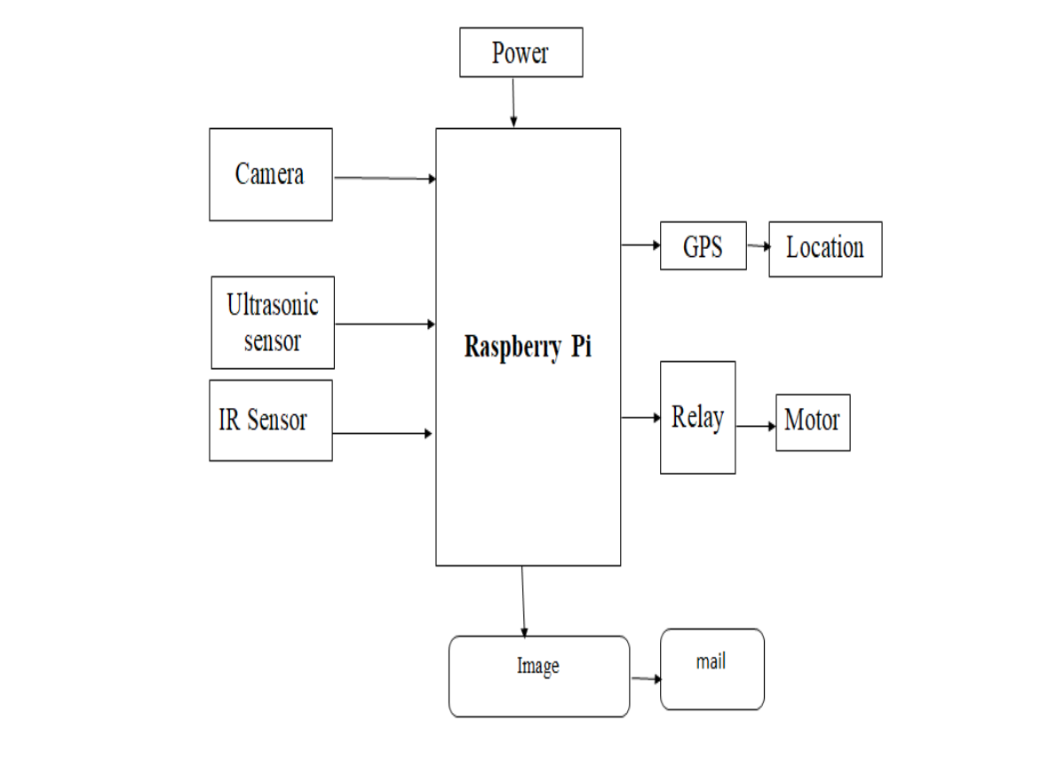

FIG 4.5: BLOCK DIAGRAM

The camera is deployed to capture the images or pictures of the current scenario to the Raspberry Pi module in order to process the captured images. The Ultrasonic Sensor is used to pass the signals between the tracks and identify if there is any divergence in the signals. In case of any divergence, it could be stated that there is any obstacle in the track. When the IR Sensor detects any objects in the tracks and if any sends the signal through the to the camera for capturing the images. The images are then sent for processing. The entire model is connected using a power connection and the signal is sent to the concerned person through alerts by using the GSM module. The alert is given when an object is recognized. All the information is sent to the cloud server from where the information is processed and analyzed. The data is used by making use of the android application from smartphones. When the object is recognized by the sensor, the GPS module is used to track the accurate location and share this location with the concerned authority by making use of the GSM services.

**4.7 BLOCK DIAGRAM FOR PROPOSED APPROACH:**

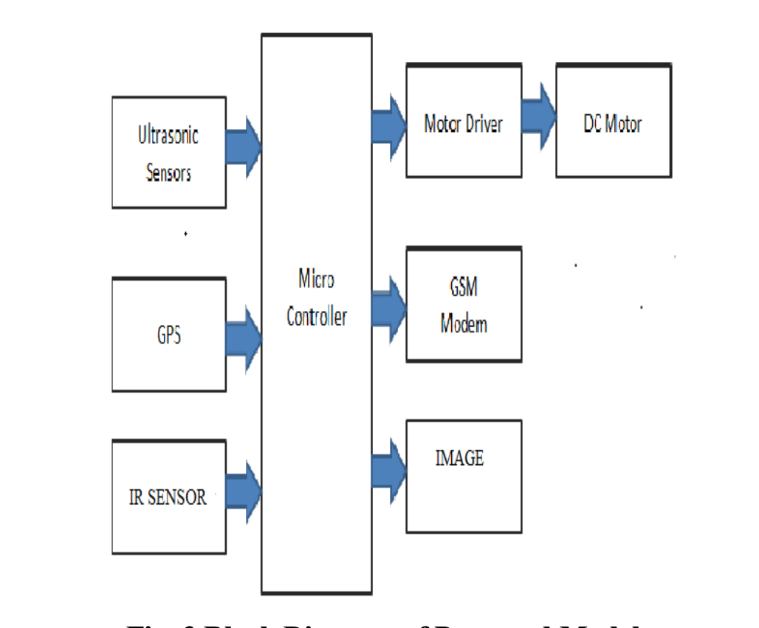

In this proposed approach, First the IR sensor and Ultrasonic sensors are connected to the microcontroller. The GPS module is connected to get the GPS coordinates of the obstacle/crack sensed or detected by the sensors. The device completely works on the basis of Dc motor; it is connected with a relay motor to control the power voltage. When the motor gets started the core of the device starts working and its procedure starts working. Then the required data through the microcontroller is sent to the user in the form of Image or SMS. For this transfer of data various protocols such as SMTP, HTTP, FTP, TCP are used in order to assure that the data is safe and efficient. Through these protocols there will be no loss of data. The GSM modem will help mobile link connections from user to device. Thus, with further actions the efficient control of the device will be taken, the solution & idea behind it will be taken by the user.

**5.IMPLEMENTATION & TESTING**

**5.1 Implementation**

**5.1.1 Ultrasonic sensor functional details:**



* Raspberry-gpio-python or RPi. GPIO, is a Python module to control the GPIO interface on the Raspberry Pi.

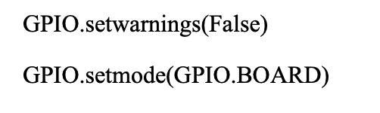

* **setwarnings** (**False**) to disable warnings.
* To specify in your code which number-system is being **used**, **use** the **GPIO**. **setmode**() function. It will activate the Broadcom-chip specific pin numbers.

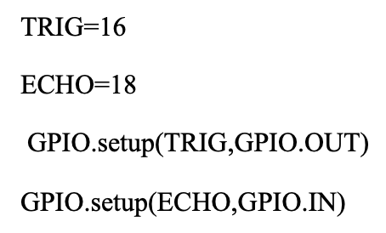

* Trig (Trigger) pin is used to trigger the ultrasonic sound pulses. Echo pin produces a pulse when the reflected signal is received. The length of the pulse is proportional to the time it took for the transmitted signal to be detected.

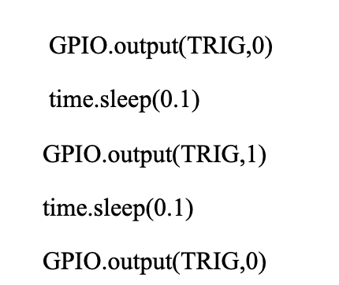

* Set TRIG as low as well as high, delay it for 0.00001 seconds.

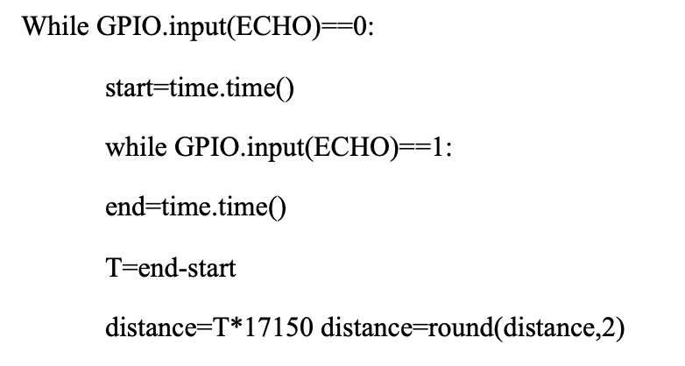

* Check whether echo is low, time to get back the pulse to sensor.
* Multiply pulse duration by 17150 (34300/2) to get distance.
* Round to two decimal points.

**5.2 IR sensor functional details:**

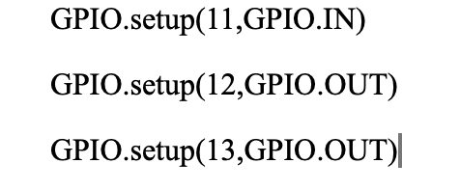

* Set GPIO11 as input.
* Set GPIO12, GPIO13 as output.

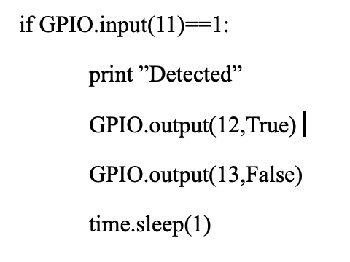

* If given input is true, then it is indicated as Obstacle/crack detected.
* After the detection the execution is suspended for a given time.

**5.3 OPENCV algorithm functional details:**

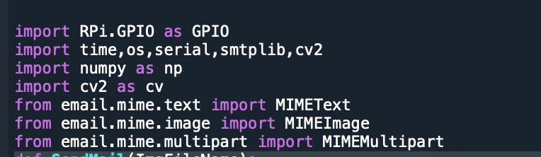

* The module used in device functional code is smtplib.
* The libraries used in this development are cv2, os.
* The Serial package is used for serial connections in microcontrollers.
* Numpy library is used in this code to handle large and multi-dimensional code.

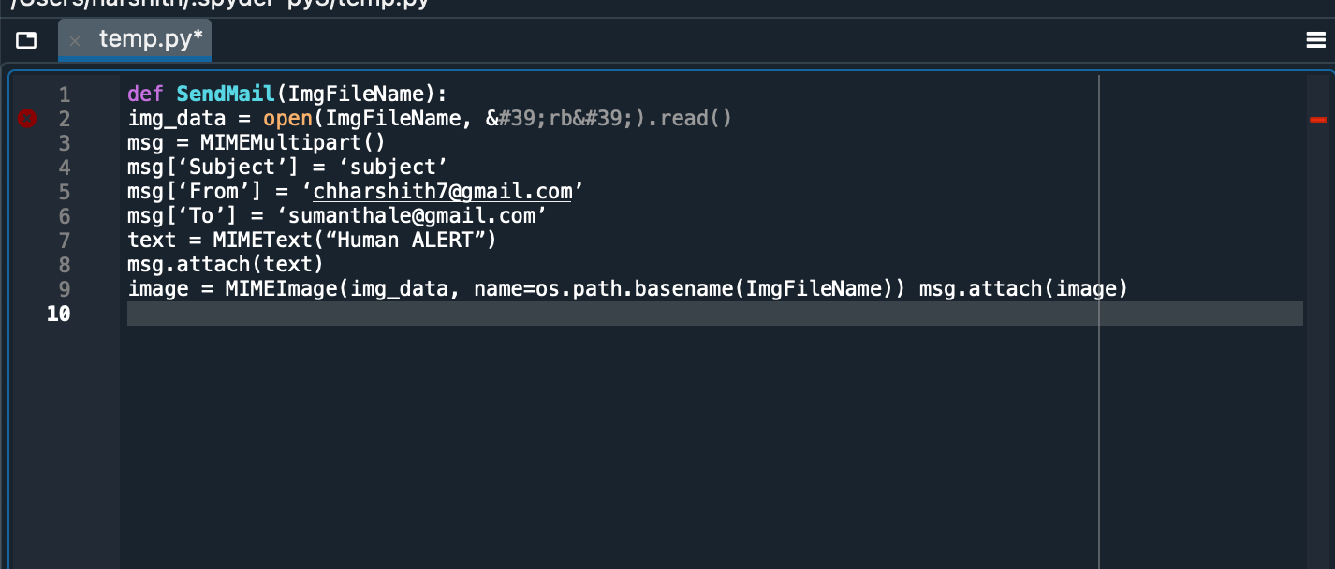

* Send Mail function is used to send the data in the form of mail using SMTP protocol.
* The User can receive from the sender and after sending the mail the user will receive a message named “HUMAN ALERT “.
* The message is attached in the form of text.
* If the sender wants to send the data in the form image the path is set to send the image.

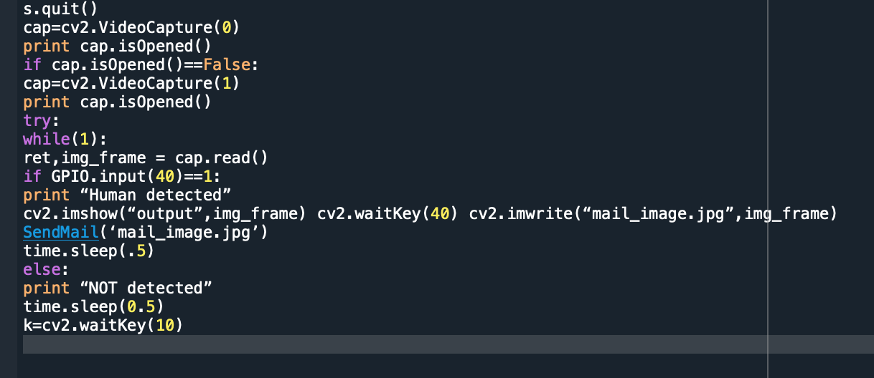

* If the sender wants to send the data in the form of any media format, he can send it efficiently because the FTP is used to effectively send the data without any loss.
* During the transmission phase there may be exceptions raised by the medium but setting the pin to high and by exception handling the exceptions are handled and the smooth transmission of media takes place.
* After transmission the execution is stopped for given seconds.

**5.2 TESTING**

**5.2.1 PERFORMANCE EVALUATION OF PROPOSED MODEL**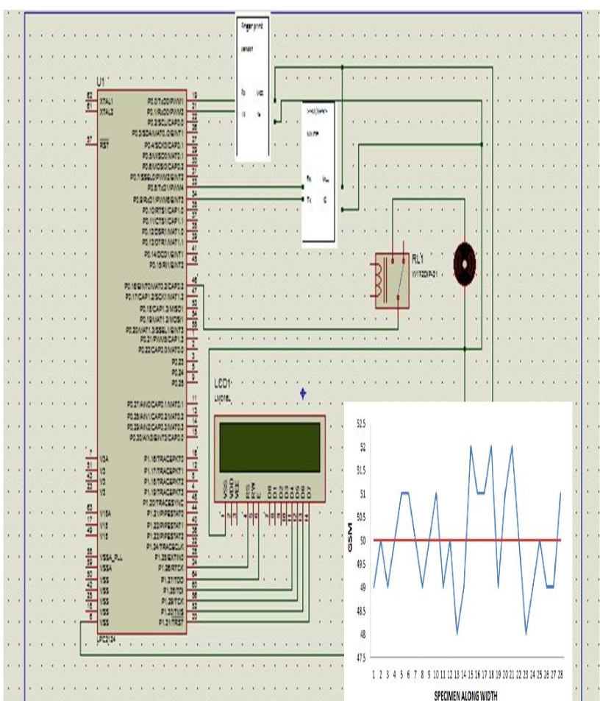

FIG 5.2.1 PERFORMANCE EVALUATION

* The performance measures observed while working with the proposed model states that the overall model is flexible and could be used for continuous monitoring of the railway tracks.

**5.2.2 EFFICIENCY OF PROPOSED MODEL**

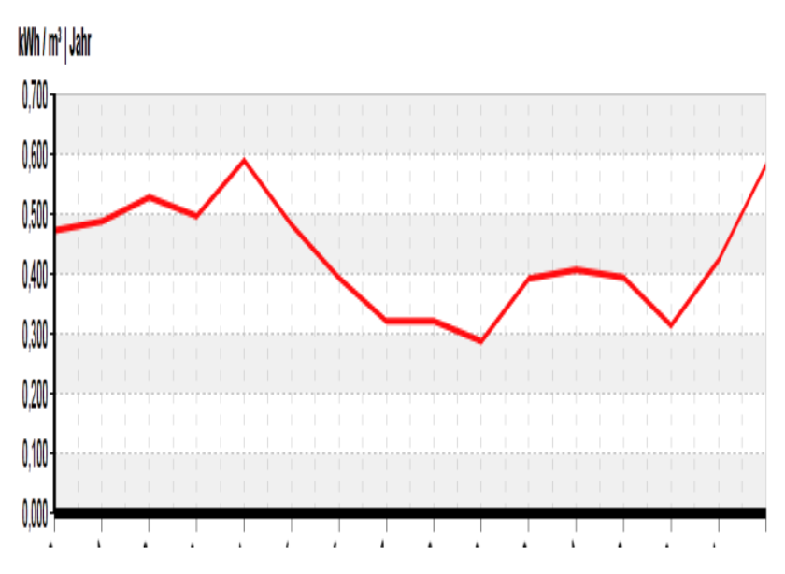

FIG 5.2.2 EFFICIENCY OF PROPOSED MODEL

* The experimental evaluation was performed on the designed model. Various parameters were used for evaluating the model. The entire model is made using LINUX and uses ARM Linux GCC 4.4.6 for compiling the data. Python and OpenCV are used for coding purposes.
* This system can effectively reduce the number of manpower required for maintaining and securing the railway services. The GSM and GPS services serve to be very helpful by alerting the information about the obstacles to the concerned authority. So, that further process is done and it can be an effective model and can also overcome existing system limitations.

**5.2.3 TESTING THE PROXIMITY OF PROPOSED MODEL:**

The Test cases in device development are range calculation, it is important for a device to perform up to its range but not less than the actual range. In this device the most significant attribute is range, as it is used to identify the obstacle/crack. So, without any change to the sensors or to the device the sensors are aligned directly to the device and by default the obstacle/crack range is measured by the sensor.

TEST CASE 1: IR SENSOR

These sensors are good for detection between 100cm-500cm (1-5 meters / 3-15 feet). The long range makes them a good alternative to sonar sensors.

TEST CASE 2: ULTRASONIC SENSOR

For ultrasonic sensing, the most widely used range is 40 to 70 kHz. The frequency determines range and resolution; the lower frequencies produce the greatest sensing range. At 58 kHz, a commonly used frequency, the measurement resolution is one centimeter (cm), and range is up to 11 meters.

**5.3 FINAL MODEL MANIFESTATION:**

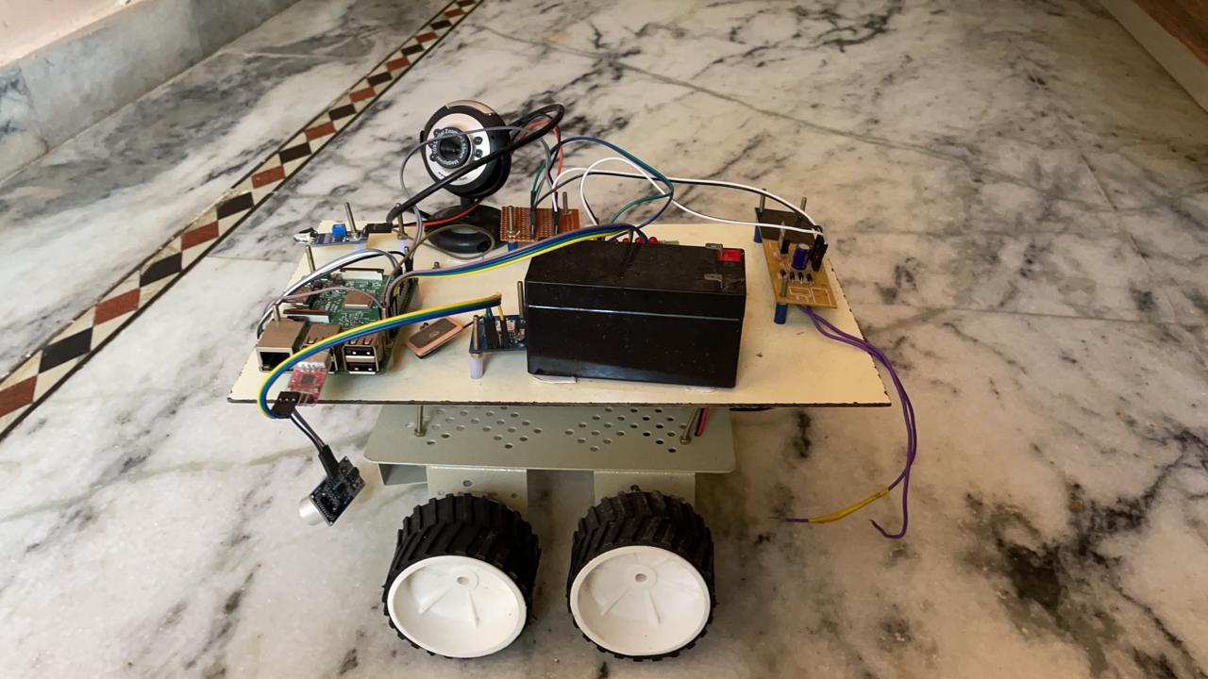

This rover is fitted with a Raspberry Pi, microcontroller, GSM modem, camera, IR sensor, Ultrasonic sensors. The camera is used to send the visualized data to the user. The Raspberry Pi microcontroller is connected with the camera, IR sensor and Ultrasonic sensor. The DC motor is connected to the microcontroller by giving power to the respective device it starts working. The relay motor is used as a bridge between motor and microcontroller. The Image is sent to the respective mail, or any other electronic signals are transferred through various means of communication. For communication there are protocols used such as HTTP,

TCP, SMTP. The GPS technology is used in order to detect obstacles/cracks and send the coordinates to the user from the device.

**6.CONCLUSION & FUTURE ENHANCEMENTS**

**CONCLUSION**

Railways are one of the biggest networks of India. In this highly populated country, it is very difficult to monitor the entire system. There are numerous accidents that tend to occur due to poor monitoring. We have proposed a model that is capable of communicating with all other connected devices in a WSN based environment. The mode comprises an IR sensor that effectively communicates if there is any obstacle in the railway tracks. When the presence of any obstacle is detected, it is captured by the Camera and sends it to the concerned authority using GSM services. The GPS module is used to get accurate information about the location of the crack or the obstacle. The Entire design is made using a Raspberry Pi microcontroller. The performance of the model was evaluated, and it was observed that it performed better than the other traditional models. Future work could include the use of machine learning techniques to automatically detect the presence of objects in a railway track.

**FUTURE ENHANCEMENTS**

Although current development presents successful working of the rover using IOT technology, there is a future scope to develop a much more advanced device with more advanced technology which satisfies all the cases which are aligned to future generation technology.

Some of the important scope for future work is mentioned below:

1. Develop a more portable device which is being fitted into various moving objects to track various paths and to detect obstacles.
2. To develop more advanced technology devices which can be used in roads as well as seaways which are portable and well equipped which are more suitable for future technology requirements.

**ABBREVIATIONS**

WSN Wireless Sensor network

GPS Global positioning system

GSM Global system for mobile communication

GPIO General purpose Input Output

IR Infrared sensor

MIME Multipurpose Internet Mail Extensions

SMTP Simple Mail Transfer Protocol

**REFERENCES**

[1] World Health Organization. (2015). Global status report on road safety 2015.World Health Organization.

[2] Vaa, T., Penttinen, M., & Spyropoulou, I. (2007). Intelligent transport systems and effects on road traffic accidents: state of the art.IET Intelligent Transport Systems.

[3] Li, L., Shrestha, S., & Hu, G. (2017, June). Analysis of road traffic fatal accidents using data mining techniques. In 2017 IEEE 15th International Conference on Software Engineering Research, Management and Applications (SERA)

(pp. 363-370). IEEE

[4] Zheng, Y., Li, Q., Chen, Y., Xie, X., & Ma, W. Y. (2008, September). Understanding mobility based on GPS data. In Proceedings of the 10th international conference on Ubiquitous computing (pp. 312-321). ACM.

[5] Mintsis, G., Basbas, S., Papaioannou, P., Taxiltaris, C., & Tziavos, I. N. (2004). Applications of GPS technology in the land transportation system. European journal of

Operational Research, 152(2), 399-409

[6] Spark, Start Something, Python (Rpi.GPIO), Contributors - M taylor, Jimblom (2021)

[7] Raspi.TV Rpi.GPIO basics, Using inputs and outputs together. Pullups and pulldowns (2021)

[8] Raspi.TV Rpi.GPIO basics, Setting up and using outputs with Rpi.GPIO(2021)